**EXPECTED VALUE**

Mean of uncertain event’s probability, regular mean formula can be used certain or constant events but for uncertain events we have to use this expected value’s formula.

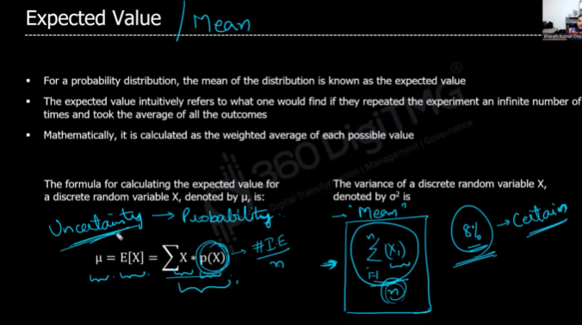

**EX:**

Sales of apple I pad is uncertain

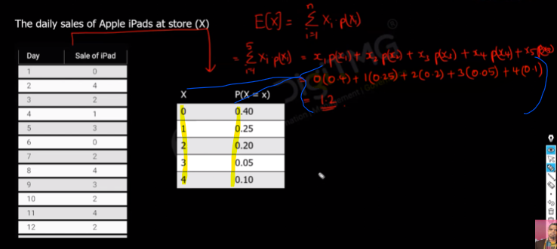

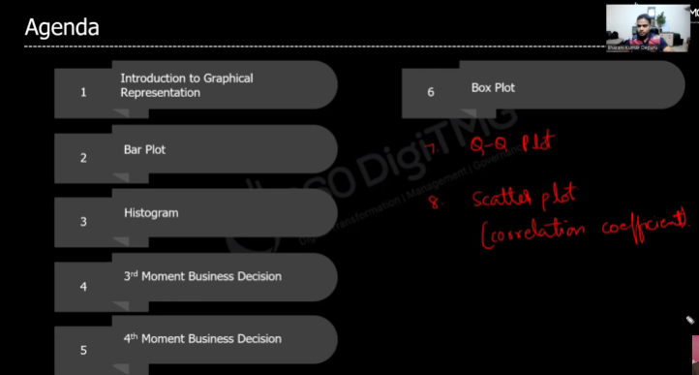

**HISTOGRAM**

Normal bar plot is not well not display large amount of data

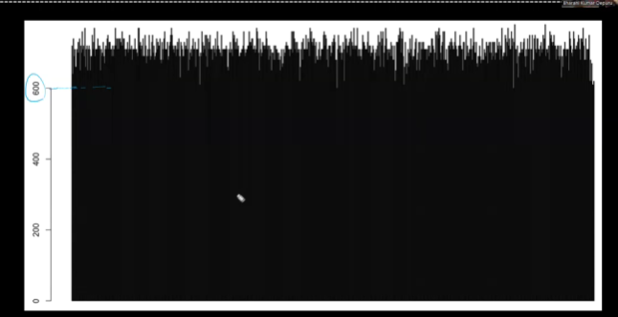

To visualize this we can use histogram which takes only one variable as x axis that helps to plot the frequency. Since it takes single variable so it is called **univariant plot**

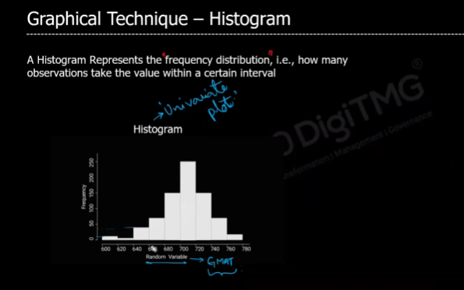

EX: consider we have 773 student total marks, histogram will calculate how many student got mark from 600 t0 620 and plots the no of student in y axis. The x axis in histogram are called bins or groups(600-620).

We can also change the y axis of histogram to probability the values starts from 0 to 1, that are called probability distribution plot, this is also called as density plot

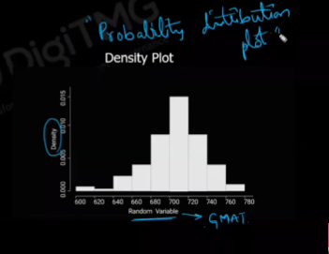

**THRID MOMENT BUSINESSS DECISION**

The above histogram helped here to visualize how data points are distributed from the mean, it will give how data is distributed unevenly(asymmetry). It indicates whether the data is skewed (leaning) towards the left or right of the mean.

**FORMULA TO CALCULATE SKEW**

It takes mean and standard deviation of the dataset

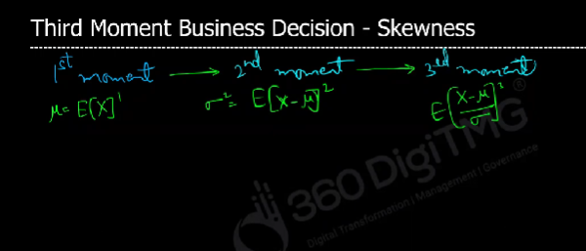

**Type of histogram data for 4th movement business decision:**

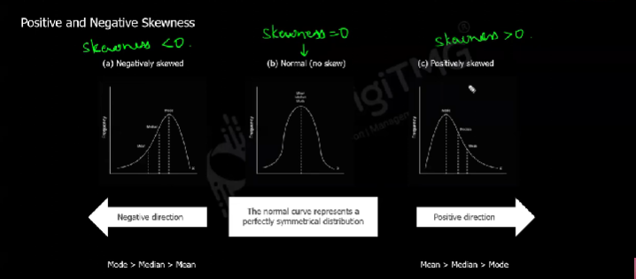

**Negative(left) skewed –** Here value of mode will be highest compare to mean, median

**Positive(right) skewed –** Here mean will be highest

**Normal (no skew) –** Data is equally distributed.

**EXAMPLE CODE TO DRAW HIST IN PYTHON**

